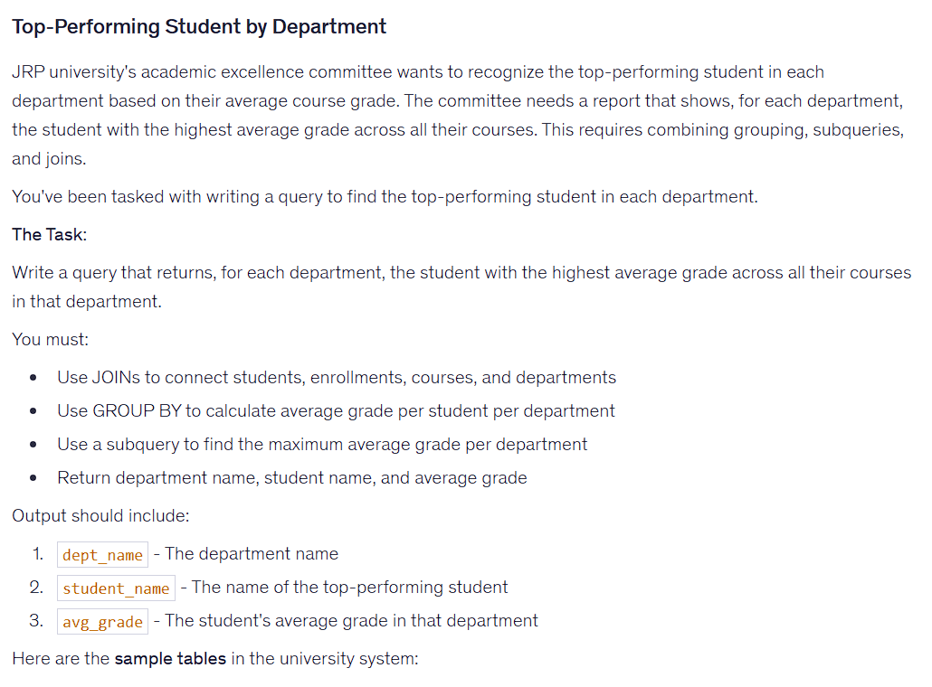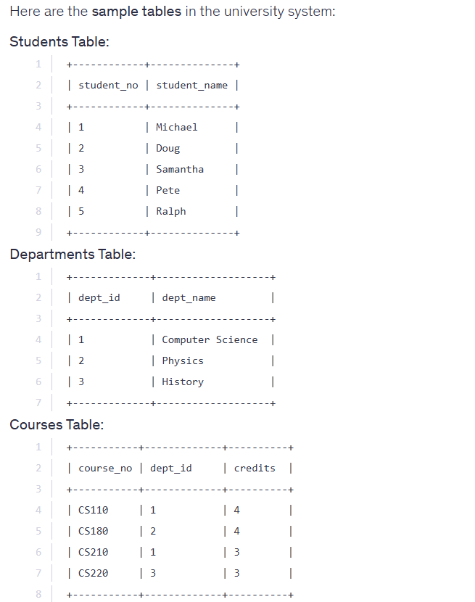
HINT


Solution:
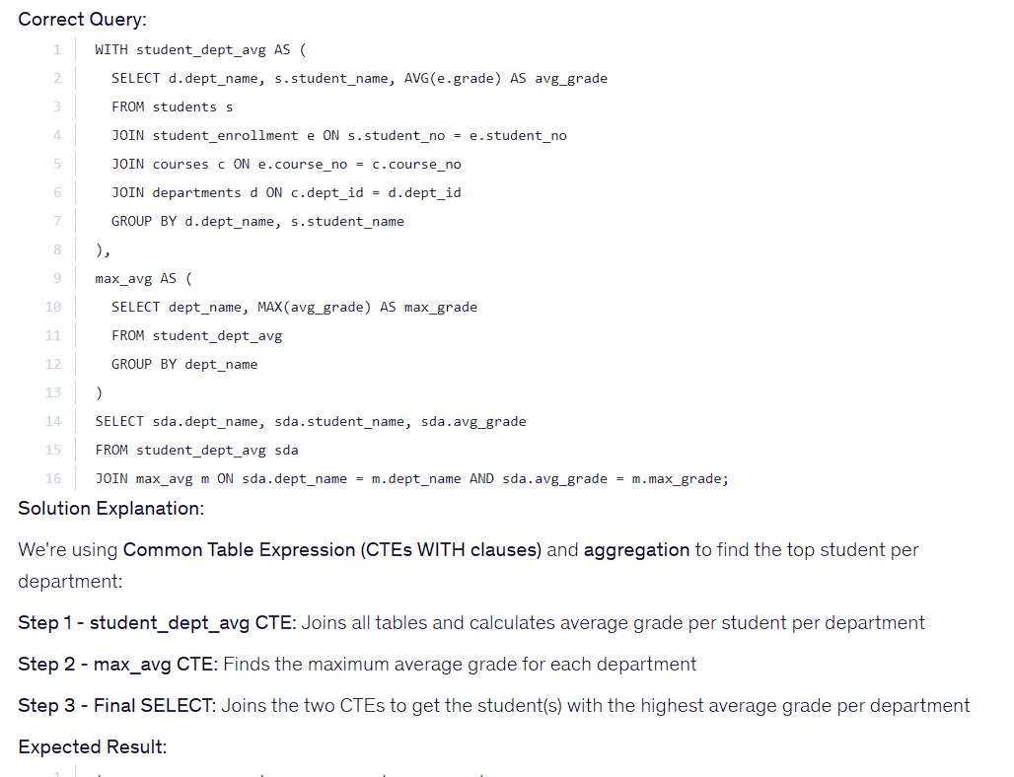
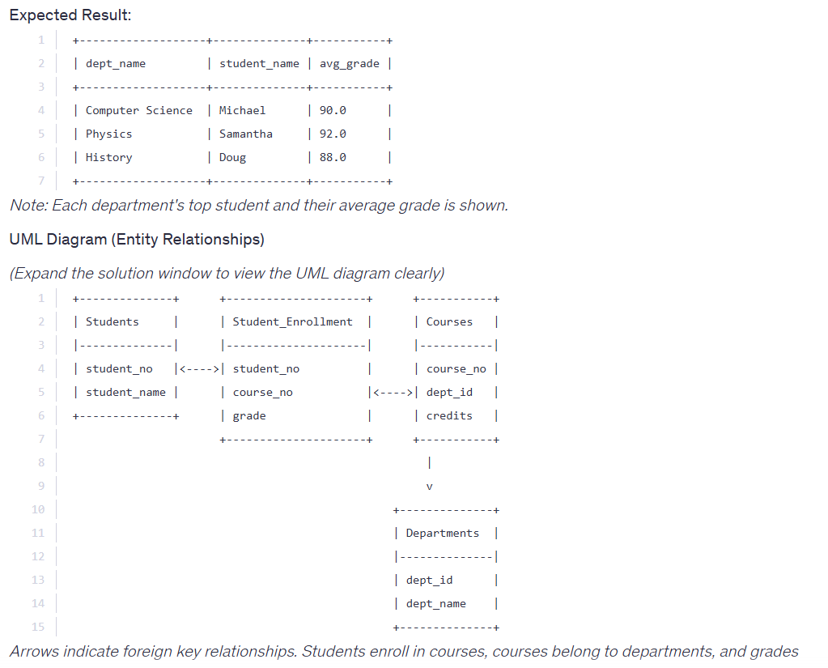

WITH student_dept_avg AS (
select d.dept_name, s.student_name, AVG(e.grade) AS avg_grade
from students s
join student_enrollment e ON s.student_no = e.student_no
join courses c ON e.course_no = c.course_no
join departments d ON c.dept_id = d.dept_id
group by d.dept_name, s.student_name
),
avg_max AS (
SELECT dept_name, max(avg_grade) AS max_grade
FROM student_dept_avg
GROUP BY dept_name
)

SELECT sda.dept_name, sda.student_name, sda.avg_grade
FROM student_dept_avg as sda
join avg_max m ON sda.dept_name = m.dept_name AND sda.avg_grade = m.max_grade

